CAUSES AND CONSEQUENCES OF IN-MIGRATION IN SHANKHARAPUR WARD 9 OF KATHMANDU, NEPAL

A
Thesis
Submitted to
Tribhuvan University
Bhaktapur Multiple Campus
Department of Rural Development
Faculty of Humanities & Social Sciences
In Partial Fulfillment of the Requirement for Master of Arts in Rural
Development

Submitted By:
Name: Kristal Suwal
Exam-Roll.No.: 2030013
T.U Regd.no: 3-2-166-124-2012

LETTER OF RECMMENDATION

This thesis titled "Causes and Consequences of In-migration in Shankharapur Ward 9 of Kathmandu, Nepal" has been completed by Mr. Kristal Suwal under my supervision in Partial fulfillment of the requirement for Master of Art in Rural Development. I hereby forward in with recommendation for evaluation.

________________________
Mr. Tirtha Raj Timsina
Supervisor
Lecturer
Central Department of Rural Development, TU

LETTER OF APPROVAL

This is to certify that the dissertation submitted by Mr. Kristal Suwal entitled "Causes and Consequences of In-migration in Shankharapur Ward 9 of Kathmandu, Nepal" has been accepted in partial fulfillment of the requirements for the Degree of Master Arts (M.A.) in Rural Development.

Thesis Evaluation Committee

Mr. Bin Bahadur Tamang  Head of the Department | …..………………
Mr. Tirtha Raj Timsina  Supervisor | …..………………
Dr.....................................  External Examiner | …..………………

ACKNOWLEDGEMENT
I would like to express my sincere and deepest gratitude to my respected supervisor, Mr. Tirtha Raj Timsina, Lecturer, Central Department of Rural Development, for his invaluable guidance, constructive suggestions, continuous supervision, and encouragement throughout the preparation of this thesis. His academic support and intellectual guidance have been instrumental in bringing this study to completion.
I am equally grateful to Mr. Bin Bahadur Tamang, Head of the Central Department of Rural Development and all the faculty members and administrative staff of the department for their valuable suggestions, academic support, and administrative assistance during the course of my study.
I would like to express my sincere appreciation to the Shankharapur Municipality for providing the necessary data and information required for this research. I am especially thankful to the administrative staff and concerned personnel of Ward No. 9 for their kind cooperation, guidance, and assistance in accessing relevant records and information during the research period.
I am also deeply grateful to all the local people and respondents of the study area who participated in the questionnaire survey and generously shared their time, experiences, opinions, and information. Their cooperation and willingness to provide the necessary data made the fieldwork possible and greatly contributed to the completion of this research.
I would also like to extend my sincere thanks to all those individuals who directly or indirectly supported me during the field survey, data collection, analysis, and preparation of this thesis. Their encouragement, cooperation, and assistance have been valuable throughout the research process.
Finally, I would like to express my heartfelt gratitude to my family members, friends, and well-wishers for their continuous encouragement, patience, moral support, and assistance throughout my academic journey. Their support and motivation gave me the strength and confidence to complete this study successfully.
I remain grateful to everyone who contributed, directly or indirectly, to the successful completion of this thesis.

Kristal Suwal
October, 2026

ABSTRACT
Migration is an important component of population change and is closely associated with socio-economic, demographic, and developmental transformation. In Nepal, increasing movement of people toward urban and peri-urban areas has contributed to changes in population distribution, livelihoods, access to services, and local development. Against this background, this study was conducted to examine the causes and consequences of in-migration in Shankharapur Ward No. 9 (Sankhu) of Kathmandu, Nepal. The study specifically aimed to analyze the causes of in-migration, assess the socio-economic and demographic characteristics of migrant households, and examine the consequences of migration at the destination.
The study was based on primary and secondary sources of data. Primary data were collected through a structured questionnaire survey, supplemented by observation and informal discussions. A complete enumeration of 89 migrant households comprising 345 persons was conducted in the study area. The collected data were processed and analyzed using SPSS and Microsoft Excel. Percentage distribution, tabulation, classification, and graphical presentation were used to analyze and present the findings.
The study found that the migrant population was predominantly literate, with an overall literacy rate of 80.9 percent, although a considerable gender gap existed between male and female literacy. The migrant population consisted of 181 males and 164 females, with a sex ratio of approximately 110 males per 100 females. The average family size was 3.88 persons per household, and the population was concentrated mainly in economically active age groups. Chhetri and Brahmin households constituted the largest proportions of migrant households, accounting for 36.0 percent and 31.5 percent respectively.
Regarding the causes of in-migration, limited infrastructure was reported as the major reason for leaving the place of origin by 34.8 percent of households, followed by limited job opportunities (27.0%) and limited market access (20.2%). These three factors together accounted for more than four-fifths of the reported reasons for migration. The majority of migrant households (73.0%) had migrated from a different district, while migration decisions were frequently influenced by close family members and relatives.
The consequences of migration indicate improvements in several aspects of household well-being. A large majority of migrant households (88.8%) reported satisfaction with their current place of residence, while 85.4 percent intended to live permanently in the study area. Access to education was the aspect most frequently reported as improved after migration, with 79.8 percent of households reporting improvement. Household income also showed a positive change: the proportion earning below Rs. 20,000 per month declined from 34.8 percent at the place of origin to 12.4 percent at the destination, while households earning Rs. 40,000 or more increased from 10.1 percent to 22.5 percent. Access to physical facilities, particularly transportation and health services, also improved after migration.
Despite these improvements, migrant households continued to face several challenges at the destination. Inadequate development funding was reported as the major problem by 39.3 percent of households, followed by insufficient health facilities (19.1%), a poor social environment (18.0%), and lack of employment opportunities (15.7%). Overall, the study shows that in-migration has contributed to improvements in the socio-economic conditions of migrant households while simultaneously creating continuing demands on local infrastructure, services, and development planning in Shankharapur Ward 9.

Acronym
No. Number
NPC National Planning Commission
CEDA Centre for Economic Development and Administration
UN United Nations
UNFPA United Nations Population Fund

Contents
Chapter One 1
Introduction 1
1.1 Background of the Study 1
1.2 Statement of the Problem 3
1.3 Objectives of the Study 4
1.4 Significance of the Study 5
1.5 Rationale of Selection of Study Area 5
1.6 Limitations of the study 6
1.7 Organization of the Study 7
Chapter-Two 7
Literature Review 7
2.1 Theoretical Review 10
2.2 Empirical Review 11
2.3 Policy Review 14
2.4 Research Gap 14
2.5 Conceptual Framework 14
Chapter-Three 17
Research methodology 17
3.1 Introduction to Study Area 17
3.2 Sample Design 17
3.3 Questionnaire Design 17
3.4 Data Collection and Processing 17
3.5 Data Analysis 18
Chapter Four 19
Socio-economic and demographic characteristics of migrants 19
4.1 Socio-Economic Characteristics 19
4.1.1 Literacy Status of Migrants 19
4.1.2 Ethnicity 20
4.1.3 Religion 21
4.1.4 Size of Land Holding 22
4.1.5 Source of Water 23
4.2 Demographic Characteristics 25
4.2.1 Age and Sex Composition of Migrants 25
4.2.2 Marital Status of Migrants (aged 10 years and above) 26
4.2.3 Family Size 27
4.2.4 Age Dependency Ratio 29
Chapter Five 31
Causes and Consequences of Migration 31
5.1 Causes of Migration 31
5.1.1 Reasons for Leaving the Place of Origin 31
5.1.2 Place of Origin 32
5.1.3 Responsible Person for Decision Making to Migrate 33
5.2 Consequences of Migration 35
5.2.1 Satisfaction with Current Place of Residence 35
5.2.2 Problems Facing at Destination 36
5.2.3 Permanency of Households in the Study Area 38
5.2.4 Changes in Some Aspects of Migrants 38
Chapter Six 40
Comparative Analysis of Main Causes and Consequences of Migration 40
6.1 Income 40
6.2 Occupation 41
6.3 Physical Facilities 42
6.4 Suggestion to the Relatives 43
6.5 Impact of Migration in Shankharapur Ward 9 (Sankhu) 44
Chapter Seven 47
7. Summary, Conclusion and Recommendation 47
7.1 Summary 47
7.2 Conclusion 48
7.3 Recommendation 49
References 51
APPENDIX: Research Questionnaire 53

Chapter One

Introduction

Background of the Study
Migration is one of the major components of population change which is basically cause by socio-economic factors. It is one of the demographic phenomena which causes significance change in various aspects of life basically the socio-economic changes It affect not one the size of the population but also change its structure and social characteristics. Migration is not only the factor of population change there is other biological factor namely fertility and mortality which have adverse effect in population change.
Migration affects not only the population size of origin but also destination point of migrant people. Socio-economic factor are the main causes why people migrant from one place to another. In addition, it is very difficult to know why some people migrate from one place to another particular place
The United Nations Multilingual Dictionary also defined migration as "a form of geographic mobility or spatial mobility between one geographical unit and another, generally involving change in residence from the place of origin or place of departure to the place of destination or place of arrival. ‟ (United Nations [UN], 1973, p. 173).
Migration is a special mobility of people by changing usual place of residence to a well-defined destination. A migrant is a person moves either from his place of birth to another area or keeps on moving stepwise or critical by changing his residence more or less frequently by being seasonal, temporary, semi-permanent, depending upon the duration or migration and reason for migration within a defined geographical area (KC B. K., Internal migration in Nepal, 2003)
Migration is a barometer of changing social, economic and political circumstances at the national and international level. In all cases, migration is a sign of wide disparities in economic and social conditions between origin and destination both caused by better and cheaper transports and communication facilities. Another common feature is unpredictable and volatile movement as the result of specific short term or long-term crises. Most of these crises produce in the first place local rather than international movements through migrants may cross boarders in search of their security (United Nations Population Fund [UNFPA], 1993).
According to classical economic theorem migration balances the distribution of population and the supply of resources. People move from poor area to rich resource. Migration is broadly divided into two divisions, one is internal and another is international migration. Internal migration is the migration within country i.e. in migration and out migration while international migration refers to the movement of people from one country to another i.e. immigration and emigration.
As a mechanism of balancing population and actual resources it is one of central interest to the study of population environmental relationship and economic development. Migration may occur from one village to another, within the districts or between the districts and within the country or outside the country people move largely because of economic motives. Similarly, selectively among migrants may also occur by age and sex. In India and Nepal, large number of adults leaving their families behind in the native village, such movements are largely due to economic motives where employment opportunities attract rural males to urban centers but the high cost of urban living compels male migrants leave their families behind.
Process of migration is as old as human society. In early days there was primitive migration in which the natural forces were vital but as the time passed on gradually different types of migration appears in a early period. Natural force, primitive people shift them from one place to another but present there are not only forced immigration but also voluntary migration can be seen. In forced migration natural force, political force, political factors play an important role to shift the residence. Nepal has a long history of migration after the implantation of malaria eradication program; the process of migration started from hill and mountain to Terai and inner Terai and low land of the country.
Our country is divided into three ecological zones namely Mountain, Hill and Terai. These three ecological zones are divided into five development regions namely Eastern, Central, Western, Mid-western and Far-western development regions. Again, these three ecological regions are divided into 14 zones and 75 districts.
The trend of migration appears both in internal and international level where, India is the major destination place of international emigrants. The flow of internal migration also is increasing rapidly during the last two decades from the Hilly and Mountain regions to Terai due to infrastructural development and availability of the social services in Terai. This trend of migration has two major effects. The first effect is lack of skillful and independent human resources in the place of origin and the second is high pressure in the social services and security in the place of destination. Internal migration is responsible to uneven distribution of population in Nepal.
The 2001 census of Nepal had included enough information to calculate four streams of migration within the country. In Nepal, the major streams of internal migration are rural-to-rural 68 percent, rural-to-urban 26 percent, urban-to-urban 3 percent and urban-to-rural 4 percent in 2001.
In the context of Nepal CEDA (Centre for Economic Development and Administration, 1977) carried out a study of immigration pattern in Kathmandu. The study focused that more than 50 percent of the migrants were of age group 20-30 years. The study also concluded that economic opportunities were the major causes of migration. The study further identified some causes of migration of people from hill areas of Central Nepal. It suggested that selective nature of age, sex, occupation, population pressure, food shortage and poverty in the hill region are the main reason for migration. The plan can control the volume of migration from hilly region the availability of intervening opportunities through investment in road and irrigation.
Unfortunately, the earthquake on April 25th 2015 and may 12th 2015 in Nepal have the massive destruction of many settlements of human population and lost many lives. The government of Nepal statistics states that 602,257 houses were fully destroyed and 285,099 houses were partially damaged with more than 8-billion-dollar losses (NPC, 2015). For facilitation the victim of earthquake Nepal government has projected many categories of sustenance tangible earthquake victim of Nepal.

Statement of the Problem
The process of migration has been gradually intensifying the existing settlement problem as well as creating new problem both at the place of origin and the place of destination. Migration is an important component in the socio economic and demographic land space of Nepal. Terai still continues to be the main recipient of both the internal and international migrants. Immigration is nowadays one of the major issues for most developing countries. Nepal is no exception and also suffering from the critical issues in migration. Nepal has culturally and ethically complex society where is the result of migration activities, which range in physical type and cultural from Indians in south and Tibetan in the north.
The cause of migration can easily be identified but it is very difficult to find out the quality of the consequences of migration. Migration has short, medium and long-term effects show their evidence from so many years' migration and accept them as part of culture and society. In such a case only a very sensible and eventful research can identify such consequences.
This study area is ward no. 9 of Shankharapur Municipality which lies in the northern part of the country and of the developing municipality of capital city Kathmandu. This municipality is facing the continuous flow of immigration day by day which in turn have to faces many consequences that is positive or negative both side by side.
What are the primary factors driving migration in the study area?
What are the social, economic, and political consequences of migration for destination area?
So, the main issue of this study is to examine the main trends, causes and consequences of immigration in the study area.

Objectives of the Study
The general objective of the study is to assess the status, causes and consequences of immigration in Shankharapur municipality of Kathmandu district. The specific objectives are as follows:
- To analyze the causes of immigration in the study area.
- To assess the existing nature and composition of migrant people.
- To explore the consequences of immigration to the destination.

Significance of the Study
This research is highly significant as it provides a comprehensive investigation into the causes, consequences, and socio-economic and demographic characteristics of migrants in Shankharapur Municipality Ward 9. Understanding these specific factors is critical for explaining the broader patterns and impacts of immigration within the context of rapid urban transformation.
On a theoretical level, this research adds to the academic body of knowledge by scrutinizing the demographic trends and underlying drivers that fuel human movement in contemporary Nepal. While the sources suggest that identifying the causes of migration is often straightforward, this study seeks to perform the more complex task of evaluating the quality of the consequences through detailed, "sensible and eventful research". By exploring these patterns within the specific framework of rapid urban transformation, the study establishes a foundational reference for academics and provides a scholarly basis for future investigations into the relationship between migration and rural development.
At the applied level, the findings offer functional insights for planners, policymakers, and development practitioners to better navigate the complexities of population shifts. By pinpointing the specific causes and consequences of immigration in Ward 9, the research facilitates the design of targeted interventions aimed at enhancing the living conditions of the local population. Furthermore, the study identifies localized dynamics that can be used to strengthen public participation and promote sustainable urban growth within the municipality. Ultimately, these practical outcomes are intended to help local authorities manage the continuous daily influx of migrants and the resulting pressure on social services and community security.

Rationale of Selection of Study Area
The choice of Shankharapur Municipality Ward 9 (Sankhu) as the focal point for this research is based on the following strategic justifications:
Shankharapur is a rapidly developing municipality on the periphery of Kathmandu that is currently experiencing a continuous, daily influx of in-migrants. This constant population movement creates an immediate and high-priority need to investigate the resulting socio-economic and demographic consequences, whether positive or negative.
The selection of Ward 9 is highly practical for a Master’s level study. With a total of 82 households, the ward provides a sample size that is manageable within the researcher's specific constraints of time, financial resources, and expert manpower, ensuring the study can be implemented with the required depth.
To ensure the study remains objective and free from researcher bias, the area was chosen through a random sampling method from the Kathmandu district level. Subsequently, a purposive sampling method will be applied to draw relevant data from the migrant population within those households.
Existing literature on migration in Nepal is largely dominated by macro-level or city-wide analyses. There is a significant lack of context-specific research that integrates demographic, socio-economic, and policy perspectives at a localized ward level, particularly in areas like Ward 9 that have seen shifts following the 2015 earthquake.
This specific ward serves as an ideal "laboratory" to identify localized dynamics that can help planners and development practitioners design targeted interventions. The findings will identify new perspectives to enhance public participation and accelerate sustainable urban development within the municipality.

Limitations of the study
This study has several limitations that should be considered while interpreting the results. The research was conducted within a limited time frame, which constrained detailed primary data collection through interviews and limited the extent of secondary data collection from local-level institutions, particularly the ward office. The sample size was also limited, and therefore may not fully represent the entire migrant population of the study area. Moreover, the study is geographically confined to Shankharapur Municipality, Ward No. 9 (Sankhu), which restricts the generalization of findings to other areas. The study largely depends on information provided by respondents, which may be influenced by personal perceptions or reluctance to disclose sensitive economic and social information. In addition, financial and resource constraints restricted extensive fieldwork, and certain groups of migrants, such as temporary or seasonal migrants, may not have been adequately covered.
Despite these limitations, the study provides valuable insights into the status, causes, and consequences of immigration in the study area. The findings are considered sufficient to meet the objectives of the study and to support future research and planning initiatives.

Organization of the Study
The proposed study will be organized into five chapters. Chapter One will provide an introduction to the study, including the background, problem statement, objectives, rationale, significance, and limitations. Chapter Two will review the relevant literature on migration, with emphasis on its causes, consequences, and the demographic characteristics of migrants. Chapter Three will describe the research methodology, covering the study area, data sources, sampling techniques, and methods of data collection. Chapter Four will focus on the analysis and interpretation of the collected data. Finally, Chapter Five will present the summary of findings, conclusions, and practical recommendations based on the study.

Chapter-Two

Literature Review
Review of literature is an essential part of the research studies. It is a way to discover what other research of our problem has uncovered. A critical review or the literature helps the researcher to develop understanding and insight into problems research works that relates to the present study. It is also a way to avoid investigating problems that has already definitely answered.
In the context of Nepal Centre for Economic Development and Administration, (CEDA, 1973) carried out a study of immigration pattern in Kathmandu. The study focused that more than 50 percent of the migrants were of age group 20-30 years. The study also concluded that economic opportunities were the major causes of migration. The study further identified some causes of migration of people from hill areas of Central Nepal. It suggested that selective nature of age, sex, occupation, population pressure, food shortage and poverty in the hill region are the main reason for migration. The plan can control the volume of migration from hilly region the availability of intervening opportunities through investment in road and irrigation.
Ravenstein (1885) is the father of migration studies. He had brought the concept of migration and its stream. He explained that push and pull factors are the foundation of theory of migration. This article which is linked with demographic and economic variable in relation to distance and volume of migration also depends on distance. Ravenstein “Law of migration” states that migration occurs with stream and counter stream in each region as nations and universal. It has been widely accepted. Lee (1966) explained that the decision to migrate is governed by “push and pull factors”. She related pull factors to the destination which are attractive and always positive. On the other hand, push factors are explained as related to which are repulsive and always negative. Before migrating, individuals consider several aspects, including factors associated with the origin, factors related to the destination, intervening obstacles such as distance, transportation, and cost, as well as personal factors like age, sex, and education.
Stewart (1950) have attempted to explain the movement of individual. His theory is known as “Gravitational Theory” which states that the numbers of persons who move between two areas are directly proportional to the two populations and inversely proportional to the distance between them. Zipf was agreed with Ravenstein's view regarding to irritation. Gravity Model m=a* u/v, where, a is the number of migrants in a given stream. u and v independent variables (factors of attraction and distance) and a is the constant of proportionality. Zipf (1946) formulated “The principle of least effort”. His model was based on Ravenstein's theory of migration. He was agreed with Ravenstein's view regarding migration is inversely related to the distance to be travelled. According to him, the greater distance is effort required to overcome the difficulty and therefore the similar is the number of migrants. Similarly, the lesser the distance, the lesser is the efforts to overcome, as a result the greater is the number of migrants. Todaro (1976) has given the most significant contribution the large volume of migration literature. His view on migration mechanism can be explained by the differences in expected rather than actual earnings between two places. He has formulated migration models in four different features as: a. Migration is estimated primarily by national income considerations of relative benefits which are mostly traditional and psychological. b. The decision to migrate depends on expected rather than actual wage differentials. c. The probability of obtaining employment in the new sectors is inversely related to the unemployment rate in the new sector. d. Migration rates of new employment opportunity growth rates are not only possible but rational as well as and even likely in the face of wide new or old expected income differentials.
Gurung (1984) analyzes in his book ‘Inter Regional Migration in Nepal’, showed that population pressure, land holding, shortage of food grain, environmental stress in mountain/hill were found as the push factors and fertile land, resource government incentives, planned resettlement, physical facilities, presence of friends and relatives in the Terai were found as the pull factors. Facilities, presence of friends and relatives in the Terai were found as the pull factors.
K.C. (1998) studied the micro and macro level of rural analysis. Formal migration in Nepal based on data of Population Census 1961 and 1971 concluded that differentials in income derived from the agriculture government resettlement project in Terai, government increased investment in irrigation, industrial activities, and administrative activities in specific towns were structural determinants of migration. For the micro level analysis, K.C. has shown that literary rate, age distribution, local social factors like family kinship were found major factors for the migration.
Kunwar (1993) analyzed the causes and consequences of internal migration phenomenon through the multivariate analysis as well as path model. He concluded that the low productivity and insufficient land are main causes of leaving origin and availability of physical facilities and extension of business opportunities reduce the causes of leaving origin but moving of relatives and friends and education increase the causes of leaving origin. He also concludes that the age factor also plays significant role in the process of migration.
During the time of Maoist insurgency people migrated from hill to Terai (Niroula, 2016). Other factors, which accelerated this process, were probably the population pressure creation of infrastructure and concentration of development activities that created opportunities for employment in the Terai. As a result, there are considerable changes in demographic, socio-economic and environmental condition both at the origin and destination.
Mabogunje (1970) applied a concept of system theory in the system of rural to urban migration operates having economic, social, technological and government component. He attempted to relate trends, patterns and implications of rural to urban migration with general system theory (KC,1993:3) the ground migration to be systematic, influenced by an environment and control mechanism may change the whole system.
Another study done by Gurung (1974) was on planned resettlement in western Terai. It was based on survey of Banke and Bardiya resettlement project. It included a view of resettlement scheme, characteristics of settlers in project area. Ethnic classification, income size of land holding and livestock of migrants.
Subedi (1996) studied on population growth and migration in Kathmandu city in which he concluded the internal and international migration are the main factors to increase population in Kathmandu city.
KC (1993) studied urbanization and migration in Nepal in which that concluded that international migration involving unrestricted emigration and immigration can be detrimental to the national interest but that should be beneficial if it is regulated properly.

Theoretical Review
Migration is a complex phenomenon influenced by economic, social, and environmental factors. Several theories have been developed to explain the process of migration. Ravenstein (1885), known as the father of migration studies, introduced the concept of migration streams and counter-streams, emphasizing that migration flows occur systematically between regions. He also highlighted the importance of distance in migration patterns. Lee (1966) extended this idea through the push–pull framework, explaining that migration decisions are influenced by factors at the origin (push) and destination (pull), as well as intervening obstacles such as distance, transportation, and cost. Personal characteristics like age, sex, and education further shape migration decisions. Zipf (1964) proposed the Gravitational Theory, suggesting that the number of migrants between two areas is directly proportional to their populations and inversely proportional to the distance separating them. Todaro (1976) added an economic perspective, emphasizing that expected income differentials, rather than actual earnings, largely drive migration. Together, these theories provide the conceptual foundation for understanding the causes and patterns of migration in Ward 9, Sankhu.
Building on these classical models, later scholars have developed more nuanced perspectives. The new economics of migration (Stark, 1991) shifts the unit of analysis from the individual to the household, arguing that migration is a collective strategy to diversify income and reduce risk, which helps explain why even non-poor households in rural Nepal may send members to urban areas or abroad, using remittances for education, housing, and social investments. Migration systems theory (Massey et al., 1993) stresses that migration is not random but structured over time by historical, social, and institutional links between origin and destination areas; in the Nepali context, this is visible in established corridors from specific villages to large cities or foreign labour markets, where existing migrants inform newcomers and stabilize routes. The segmented labour-market theory (Piore, 1979) explains that migrants often fill low-wage, insecure secondary-sector jobs that local workers avoid, such as construction, domestic work, and daily wage labour, reinforcing inequalities between residents and in-migrants in urban wards like Sankhu. Social capital and network theory (Granovetter, 1973; Portes, 1998) highlight how kinship, caste, and locality ties facilitate migration by providing information, loans, shelter, and job referrals, making mobility more feasible for certain groups and producing spatial clustering within wards. Finally, critical and autonomy-of-migration perspectives (Mezzadra & Neilson, 2013; Bhagat, 2025) treat migration as an active, resistant practice through which people creatively bypass restrictive laws, use informal channels, and negotiate precarious conditions to pursue better livelihoods, underscoring the agency and everyday strategies of in-migrants in peri-urban and urban spaces like Ward 9, Sankhu.

Empirical Review
Empirical studies in Nepal and similar contexts provide insights into migration trends and consequences. CEDA (1977) observed that over 50 percent of migrants in Kathmandu were aged 20–30 years, with economic opportunities being the primary cause. Gurung (1984) identified population pressure, land scarcity, and environmental stress in the hills as push factors, and fertile land, government incentives, and social networks in the Terai as pull factors. K.C. (1998) analyzed both micro and macro-level determinants of migration, including literacy, age distribution, family kinship, and government resettlement projects. Kunwar (2015) applied multivariate analysis and found that low productivity and insufficient land prompted migration, while availability of facilities and presence of relatives influenced the decision to move. Niroula (2016) noted that during the Maoist insurgency, migration from hills to Terai accelerated due to population pressure, infrastructure development, and employment opportunities. These studies demonstrate the relevance of economic, social, and environmental factors in driving migration and highlight the need for a localized study in Ward 9, Sankhu.
Building on these earlier findings, more recent empirical work in Nepal has further clarified the causes and consequences of in-migration, especially in peri-urban and urban settings similar to Sankhu. Studies on municipalities such as Ratnanagar, Kirtipur, and Pokhara show that in-migration is increasingly driven not only by land scarcity and agricultural distress but also by the growth of construction, services, and small industries around urban centres, reinforcing the neoclassical and Todaro-type expectation-based models. In these places, younger age cohorts (similar to CEDA’s 20–30-year-old group) continue to dominate in-migration flows, confirming that economic opportunity and labour-market expectations remain central push–pull forces. Parallel studies also underline that migration decisions are shaped by household-level strategies, as predicted by the new economics of migration; even relatively non-poor rural households send members to cities or abroad to diversify income and finance education, housing, or marriage costs, as seen in later research on remittance-receiving households across Nepal.
In addition, empirical work on migration systems and social networks supports K.C.’s (1998) and Kunwar’s (2015) emphasis on kinship and relatives. Researchers have found that once migration routes are established—from specific hill villages to particular Terai towns or urban wards—new migrants tend to follow the same paths, relying on relatives for information, credit, and housing. This pattern helps explain why in-migration is often clustered in certain neighbourhoods or streets within municipalities, mirroring findings from Gurung (1984) and Niroula (2016) that migration is not random but embedded in social and spatial structures. In peri-urban wards like Sankhu, such networks likely intensify when infrastructure improves and road connectivity increases, making it easier for people from nearby rural areas to move in and settle informally.
On the consequences side, empirical studies in Nepali towns and municipalities consistently report mixed outcomes. On the positive side, in-migration supplies labour for construction, services, and small businesses and supports local economic growth, echoing CEDA’s observation that Kathmandu’s growth was partly fuelled by in-migration. Remittances sent by in-migrants or through international migration also contribute to household welfare, education, and housing in both receiving and sending areas. However, unplanned in-migration has also led to overcrowding, informal settlements, pressure on housing and sanitation, and environmental degradation, especially in peri-urban fringes where land-use controls are weak. Studies of municipalities undergoing rapid urbanization find that in-migration often results in the conversion of agricultural land into residential plots, rising land prices, and declining local services, suggesting that while the causes of migration are economic and social, the consequences are deeply spatial and institutional.
Finally, governance-oriented empirical studies highlight that local governments often lack adequate planning and data to manage in-migration, even though the phenomenon is central to urban growth. Research on municipalities in Nepal shows that Ward-level authorities frequently struggle with housing, water, solid-waste management, and education due to sudden population increases driven by in-migration. Some recent studies recommend that local authorities integrate migration into urban planning, improve household-level data collection on in-migrants, and involve both local residents and in-migrants in decision-making. For Ward 9, Sankhu, this implies that understanding the causes and consequences of in-migration must go beyond repeating national-level findings and instead examine how local push–pull factors, household strategies, social networks, and municipal governance interact on the ground. In this sense, earlier empirical work by CEDA, Gurung, K.C., Kunwar, and Niroula provides a strong base, but a localized study in Sankhu is necessary to capture the specific dynamics of in-migration in a peri-urban ward undergoing rapid transformation.

Policy Review
Migration in Nepal has been shaped by both national and local policies. National policies, such as the Nepal Migration Policy and urban development strategies, aim to regulate population movement, improve resettlement programs, and create opportunities in underdeveloped regions. Local-level initiatives, including ward and municipal development plans, focus on infrastructure development, provision of basic services, and resettlement schemes to manage migration effectively. For example, previous resettlement projects in western Terai (Gurung, 1974) aimed to relocate populations from densely populated hill areas, emphasizing land distribution, income support, and social integration. Understanding these policies is essential to assess whether migration in Ward 9 aligns with policy objectives and to identify gaps where local planning can be improved.

Research Gap
Despite extensive studies on migration in Nepal, several gaps remain. Most studies are macro-level or city-wide, lacking focus on specific wards like Ward 9, Sankhu. Few studies integrate demographic, socioeconomic, and policy perspectives simultaneously at the local level. Additionally, there is limited recent research reflecting post-2015 changes in migration patterns due to infrastructure development and urban expansion. Finally, little attention has been given to local planning implications and migrant integration at the ward level, highlighting the need for this study to provide context-specific insights and support evidence-based planning.

Conceptual Framework
The conceptual framework for this study illustrates the relationship between push-pull factors, personal characteristics, migration decisions, and their socio-economic consequences (Figure 2.1).

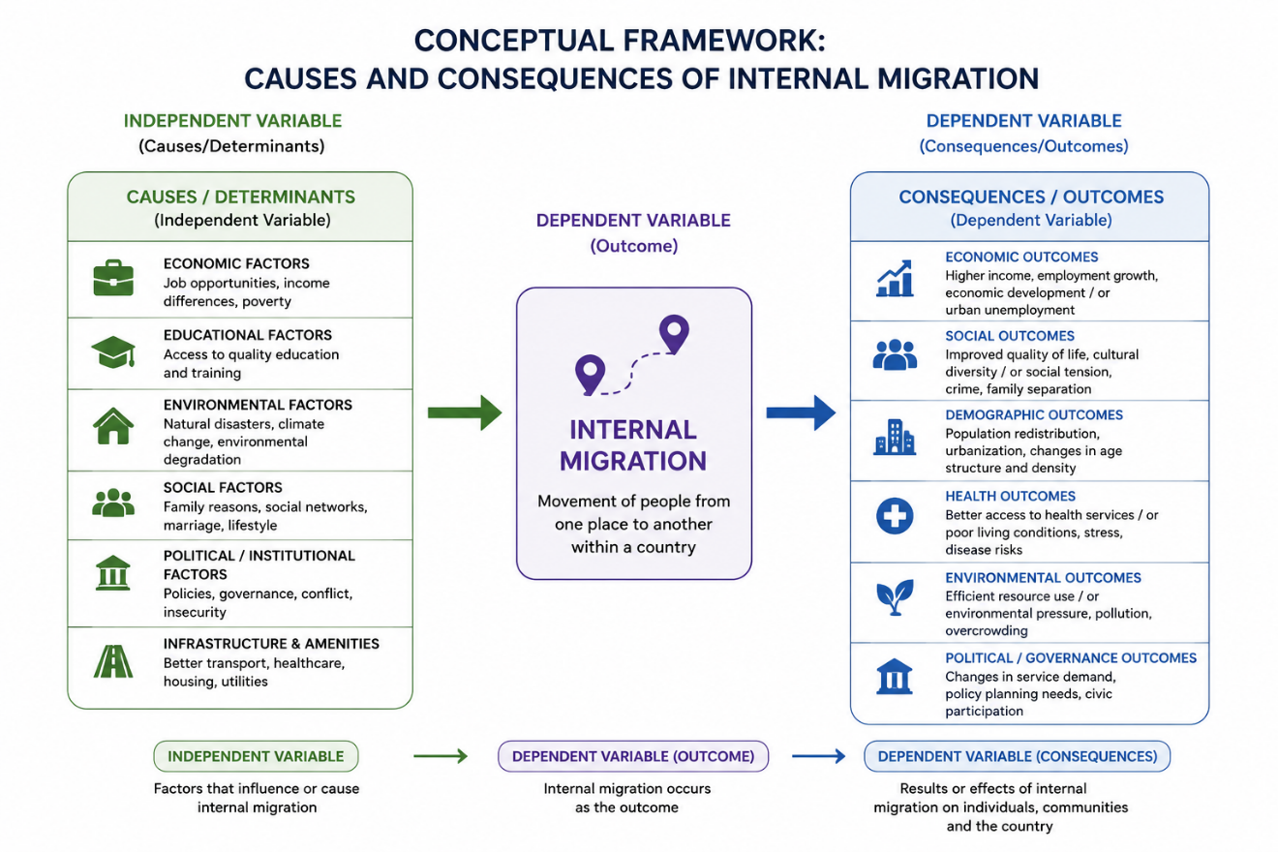

Figure 2.1 Conceptual Framework of Migration Study
The conceptual framework of this study explains the relationship between the causes and consequences of internal migration. The framework identifies various socio-economic, environmental, and demographic factors as independent variables that influence people’s decision to migrate from one place to another within the country. Factors such as poverty, unemployment, lack of educational and health facilities, natural disasters, and search for better opportunities are considered major causes of internal migration.
These factors contribute to the movement of people from rural to urban areas or from one region to another in search of improved living conditions. Internal migration itself acts as the central process connecting the causes and consequences.
The dependent variables in the framework are the consequences or outcomes of migration. Internal migration may produce both positive and negative effects on migrants, families, and society. Positive consequences may include increased income, improved access to services, and better employment opportunities, while negative consequences may include urban overcrowding, pressure on infrastructure, unemployment, family separation, and social adjustment problems.
The framework guides the research methodology, data collection, and analysis, ensuring that the study captures the causes and consequences of migration in Ward 9, Sankhu.

Chapter-Three

Research methodology

Introduction to Study Area
This section describes the study area selected for the study. The study area was selected to examine the characteristics of migrant households, their places of origin, reasons for migration, conditions before and after migration, and the changes experienced after migration. The study was based on information collected from sampled households within the study area.

Sample Design
The study used household-level information collected from 89 sampled households. The households were considered for the study according to their migration experience and the information required for the study. The distribution of the sampled households by year of migration is presented below.
Table 3.1: Distribution of sampled households by year of migration
Year | Number of households
2074 | 9
2075 | 5
2076 | 8
2077 | 2
2078 | 12
2079 | 14
2080 | 9
2081 | 11
2082 | 16
2083 | 3
Total | 89
Source: Field Survey 2026
The table shows that the number of sampled migrant households varied across the years. The highest number of households, 16, migrated in 2082, followed by 14 households in 2079 and 12 households in 2078. The lowest number was recorded in 2077, with 2 households. Overall, 89 households were included in the study.

Questionnaire Design
Questionnaires were designed in such a way that it produces all required data needed to fulfill the objectives of the study. Questionnaires are in three sections those are household questionnaire and questionnaire related to causes and consequences of in migration but mainly household questionnaire are used for analysis.

Data Collection and Processing
During the research study the data has been collected with the help of both structure and non-structured questionnaire, the questionnaires have included all the questions, which are needed to collect the information related to household and socio-economic activities. After the collecting of data processes the collected data has been done for 15 drawing out meaningful result, data processing has been done using software package SPSS and Excel.

Data Analysis
Data has been collected from the field survey, so it needed to be analyzed to get fruitful results, the collected data has been analyzed by using SPSS programs. The result has been presented in such way: a. b. c. d. Percentage distribution Use of bar and diagram Tabulation and classification Graphical presentation

Chapter Four

Socio-economic and demographic characteristics of migrants
This is the description of population which provides demographic, socio-economic and cultural characteristics of households of the study area, such as literacy status, ethnicity, religion, age and sex distribution, marital status, family size etc.

Socio-Economic Characteristics
This section presents some selected socio-economic indicators of the study area population. It defines many variables such as literacy status of migrants, ethnic composition, land ownership etc.

Literacy Status of Migrants
Literacy is one of the most important social characteristics of a population, as it has a direct bearing on employment opportunities, awareness, and the overall capacity of individuals to adapt to a new social and economic environment after migration. In this study, an attempt has been made to examine the literacy status of the migrant population of Shankharapur Ward 9 (Sankhu), considering the population aged 5 years and above. Based on the responses obtained through the questionnaire survey, the distribution of the migrant population by literacy status and sex is presented in the table below.
Table No. 4.1.1: Distribution of Migrants by Literacy Status and Sex (Population Aged 5 Years and Above)
Literacy Status | Male No. | Male % | Female No. | Female % | Total No. | Total %
Literate | 164 | 93.71 | 107 | 66.88 | 271 | 80.90
Illiterate | 11 | 6.29 | 53 | 33.13 | 64 | 19.10
Total | 175 | 100.0 | 160 | 100.0 | 335 | 100.0
Source: Field Survey, 2026.
Table No. 4.1.1 shows that, among the migrant population aged 5 years and above, 271 persons (80.9%) are literate while 64 persons (19.1%) are illiterate. Literacy is markedly higher among males, at 93.7 percent, compared with 66.9 percent among females, and correspondingly the illiteracy rate among females (33.1%) is more than five times that among males (6.3%). This gender gap in literacy is consistent with the wider Nepalese pattern in which older-generation women have historically had less access to formal schooling than men, and it suggests that female migrants in the study area may face relatively greater constraints in accessing information, services and employment opportunities at the destination than their male counterparts.

Ethnicity
Nepal is a multi-cultural, multi-ethnic and multi-religious country, home to a wide variety of ethnic groups, each with their own distinct customs and traditions. In this context, it is worth investigating whether certain ethnic groups have been more involved in migration than others. Based on the responses obtained through the questionnaire survey, the distribution of migrant households by ethnicity is presented in the table below.
Table No. 4.1.2: Distribution of Migrant Households by Ethnicity
Ethnicity | No. of households | Percentage (%)
Brahmin | 28 | 31.46
Chettri | 32 | 35.96
Janajati | 23 | 25.84
Dalit | 6 | 6.74
Total | 89 | 100
Source: Field Survey, 2026.
Table No. 4.1.2 shows that out of 89 migrant households, Chhetri households are in highest number with 36.0 percent, followed by Brahmin with 31.5 percent. Janajati households cover 25.8 percent and Dalit households are lowest with only 6.7 percent. This shows that Brahmin and Chhetri together make more than two third (67.5%) of the total migrant households in the study area, while Dalit households have migrated in a much smaller number. This suggests that migration in the study area is not evenly distributed across ethnic groups, with Brahmin and Chhetri households showing a notably higher propensity to migrate than Dalit households.

Religion
Nepal was declared a secular state by the reinstated parliament in 2006, a status subsequently upheld by the Interim Constitution of 2007 and retained in the Constitution of Nepal, 2015. This declaration reflects the state's formal commitment to treat and respect all religions practiced by the Nepalese people equally. However, the Hindu religion has traditionally remained the majority religion of the country, followed by Buddhist, Muslim, Kirat and Christian populations, among others; the National Population Census 2021 recorded 81.19 percent of the population as Hindu, 8.21 percent as Buddhist, 5.09 percent as Muslim, 3.17 percent as Kirat and 1.76 percent as Christian (National Statistics Office [NSO], 2021). In this study, an attempt has also been made to examine whether there is any relationship between the religion of the migrants and the process of in-migration in the study area. Based on the responses obtained through the questionnaire survey, the distribution of migrant households by religion is presented in the table below.
Table No. 4.1.3: Distribution of Migrant Households by Religion
Religion | No. of households | Percentage (%)
Hindu | 60 | 67.42
Buddhist | 23 | 25.84
Muslim | 0 | 0.00
Christian | 6 | 6.74
Total | 89 | 100
Source: Field Survey, 2026
Table No. 4.1.3 shows that out of 89 migrant households, Hindu households form the large majority with 67.4 percent, followed by Buddhist households with 25.8 percent and Christian households with 6.7 percent. No Muslim household was recorded among the migrant households in the study area. While Hindu households remain the majority among migrants, consistent with their national majority status, their share among the migrants (67.4%) is notably lower than their share nationally (81.19%, NSO, 2021), while Buddhist households appear over-represented (25.8% against a national 8.21%). As these figures cover the complete population of migrant households in the study area rather than a sample drawn from it, this gap reflects an actual difference in religious composition between the study area and the national population, rather than a limitation of sampling.

Size of Land Holding
Land ownership is one of the key indicators of the economic status of a household, and it is also directly relevant to how migrant status is recognized in the study area. During the course of this study, an inquiry was made with the administrative body of the municipality regarding the criteria used to grant migrant status to in-migrating households. It was learnt that a change in provision was introduced in 2076 B.S. [year to be confirmed], under which a migrant household is required to hold some land in its own name within the municipality in order to be granted migrant status. Prior to this provision, households without any land ownership were also able to obtain a migration certificate. In view of this administrative context, this study examines not only the broader division between land-owning and non-land-owning migrant households, but also the variation in the size of land holding among the households that do own land.
Table No. 4.1.4: Distribution of Migrant Households by Size of Land Holding
Size of Land Holding | No. of Households | Percent (%)
Ropani | 16 | 17.98
Aana | 62 | 69.66
Paisa | 0 | 0.00
Daam | 0 | 0.00
Others | 11 | 12.36
Total | 89 | 100
Source: Field Survey, 2026.
Table No. 4.1.4 shows that all 89 migrant households in the study area reported owning some land, with no household falling into a landless category. This is consistent with the administrative provision noted above, under which land ownership has become a precondition for obtaining migrant status in the municipality. Among the land-owning households, however, there is considerable variation in the size of holding. The majority of households, 69.7 percent, own land measured in Aana, a comparatively small unit of land measurement, while 18.0 percent hold larger parcels measured in Ropani. The remaining 12.4 percent hold land under other or mixed measurement categories. This indicates that while land ownership is now near-universal among migrant households, the actual size of land held by most of these households remains modest.

Source of Water
Access to a reliable source of drinking water is a basic necessity and is often regarded as one of the physical facilities that influences a household's decision on where to settle. Water, as such, is not a scarce resource in the study area, as there are multiple water source points (locally known as muhan) from which water is distributed to households, serving both local and migrant populations alike. Drinking water itself is available in adequate quantity to meet household needs. However, for those requiring a greater quantity of water, such as for house construction or irrigation, a considerable number of households opt for boring (tube-well) to fulfil this additional demand. Based on the responses obtained through the questionnaire survey, the distribution of migrant households by their main source of drinking water is presented in the table below.
Table No. 4.1.5: Distribution of Migrant Households by Source of Drinking Water
Source of Water | No. of Households | Percent (%)
Piped | 48 | 53.93
Boring | 35 | 39.33
Well | 6 | 6.74
Total | 89 | 100
Source: Field Survey, 2025.
Table No. 4.1.5 shows that more than half of the migrant households, 53.9 percent, rely on piped water as their main source of drinking water, while 39.3 percent depend on boring (tube-well) and 6.7 percent depend on well water. All 89 migrant households reported access to at least one of these sources, confirming that water is not a scarce resource for migrant households in the study area. The considerable share relying on boring (39.3%) is consistent with the pattern noted above, whereby households use boring primarily to meet additional water requirements such as construction and irrigation, rather than because piped drinking water is unavailable to them.

Demographic Characteristics

Age and Sex Composition of Migrants
Age and sex composition is one of the most important demographic parameters, as it has a direct bearing on the volume, direction and pattern of migration. It also provides a basis for assessing the potential workforce and dependency burden of the migrant population. Based on the responses obtained through the questionnaire survey, the distribution of the migrant population by five-year age group and sex is presented in the table below.
Table No. 4.2.1: Distribution of Migrant Population by Five-Year Age Group and Sex
Age Group | Sex of the Migrants |  |  |  | Total | Percentage (%)
Age Group | Male | Percentage (%) | Female | Percentage (%) | Total | Percentage (%)
0-4 | 6 | 3.31 | 4 | 2.44 | 10 | 2.90
5-9 | 7 | 3.87 | 4 | 2.44 | 11 | 3.19
10-14 | 14 | 7.73 | 11 | 6.71 | 25 | 7.25
15-19 | 7 | 3.87 | 10 | 6.10 | 17 | 4.93
20-24 | 20 | 11.05 | 13 | 7.93 | 33 | 9.57
25-29 | 15 | 8.29 | 15 | 9.15 | 30 | 8.70
30-34 | 19 | 10.50 | 17 | 10.37 | 36 | 10.43
35-39 | 12 | 6.63 | 17 | 10.37 | 29 | 8.41
40-44 | 12 | 6.63 | 21 | 12.80 | 33 | 9.57
45-49 | 19 | 10.50 | 8 | 4.88 | 27 | 7.83
50-54 | 12 | 6.63 | 18 | 10.98 | 30 | 8.70
54-59 | 16 | 8.84 | 12 | 7.32 | 28 | 8.12
60-64 | 10 | 5.52 | 3 | 1.83 | 13 | 3.77
65+ | 12 | 6.63 | 11 | 6.71 | 23 | 6.67
Total | 181 | 100.00 | 164 | 100.00 | 345 | 100.00
Source: Field Survey, 2025.
Table No. 4.2.1 shows that the migrant population of the study area consists of 345 persons, of whom 181 (52.5%) are male and 164 (47.5%) are female, giving a sex ratio of approximately 110 males per 100 females. The largest concentration of the migrant population falls in the age group 30-34 years (10.4%), followed by the 20-24 and 40-44 age groups, each accounting for 9.6 percent. Taken together, the economically active age groups between 20 and 49 years account for close to half of the total migrant population, which suggests that migration into the study area is dominated by persons of working age, consistent with employment and livelihood-related motives. Among children below 15 years, the 10-14 age group is comparatively large (7.2%), while the population aged 65 years and above constitutes 6.7 percent of the total, indicating a relatively modest elderly dependent population among migrants.

Marital Status of Migrants (aged 10 years and above)
Marital status is an important demographic attribute that has a bearing on household formation, family responsibilities, and the decision-making process underlying migration. Information on the marital status of migrants by sex, obtained from the questionnaire survey, is presented in the table below.
Table No. 4.2.2: Distribution of Migrants by Marital Status and Sex
Marital Status | Sex |  |  |  | Total
Marital Status | Male |  | Female
Marital Status | No. | Percentage (%) | No. | Percentage (%) | No. | Percentage (%)
Unmarried | 69 | 41.07 | 54 | 34.62 | 123 | 37.96
Married | 99 | 58.93 | 102 | 65.38 | 201 | 62.04
Total | 168 | 100 | 156 | 100 | 324 | 100
Source: Field Survey, 2026.
Table No. 4.2.2 shows that among the migrants covered under this question, 201 (62.0%) are married and 123 (38.0%) are unmarried. The proportion married is higher among females (65.4%) than among males (58.9%), while the reverse holds for the unmarried category, where males (41.1%) outnumber females (34.6%) in proportional terms. This pattern suggests that a considerable share of migration into the study area involves married individuals, which is consistent with family-related and livelihood-related motives for migration rather than migration of unattached individuals alone. It may be noted that the total number of migrants reported under marital status (324) is lower than the total migrant population of 345 shown in Table No. 4.2.1. This is because the marital status question was administered only to migrants aged 10 years and above; excluding the 0-4 and 5-9 age groups (21 children, comprising 13 males and 8 females) from Table No. 4.2.1 reduces the population to exactly 168 males and 156 females, matching Table No. 4.2.2.

Figure No. 7: Marital Status of Migrants by Sex

Figure No. 8: Marital Status of Migrants by Sex

Family Size
Family size is closely linked to household resource pressure and is often considered one of the underlying factors behind the decision to migrate. Larger families face greater demand on limited land, income, and housing space, which can act as a push factor for out-migration from the place of origin. Information on the family size of the migrant households surveyed is presented below.
Table 1 Distribution of Migrant Households by Family Size
Family size | No. of Household | Percentage (%)
Below 5 | 69 | 77.53
5-6 | 15 | 16.85
Above 6 | 5 | 5.62
Total | 89 | 100.00
Source: Field Survey, 2025.
Table No. 4.2.3 shows that the majority of migrant households, 69 (77.5%), have a family size below 5 members. Households with 5 to 6 members account for 15 (16.9%), while only 5 households (5.6%) have more than 6 members. Taking the total number of migrant household members (345) and dividing it by the total number of migrant households (89) gives an average family size of 345 ÷ 89 = 3.88 persons per household. This predominance of small households is consistent with Nepal's broader demographic trend: the national average household size fell from 4.88 persons in 2011 to 4.37 persons in 2021 (NSO, 2021), and Bagmati Province, where the study area is located, recorded an even lower average of 3.89 persons per household, among the lowest of any province in the country. The small size of migrant households in the study area therefore mirrors both the national shift toward nuclear family structures — nuclear households (6,660,481) vastly outnumber joint households (6,096) in the 2021 census — and the specifically urban character of Shankharapur Ward 9 (Sankhu), as migrants typically relocate with only their immediate family members rather than the full extended household.

Figure No. 8: Distribution of Migrant Households by Family Size

Age Dependency Ratio
The age dependency ratio measures the economic burden that the population outside the working age places on the population within the working age group. For this purpose, the population is divided into three broad age categories: children aged 0-14 years, the working-age population aged 15-64 years, and the elderly population aged 65 years and above. The child and the elderly population together are treated as the economically dependent population, while the population aged 15-64 years is treated as the economically active population. The child dependency ratio, the old age dependency ratio and the total dependency ratio are calculated as follows:
In the context of a migration study, the age dependency ratio also serves as a useful indirect indicator of the underlying motive of migration, in addition to measuring the economic burden on the working-age population. A relatively low dependency ratio generally suggests that migration is driven primarily by working-age individuals in search of better earning opportunities, since such migrants are less likely to bring dependent children or elderly members along with them. A comparatively higher dependency ratio, on the other hand, may point toward motives other than employment alone: a high old age dependency ratio could reflect migration undertaken for access to better medical facilities or a wish to remain close to relatives in old age, while a high child dependency ratio could reflect migration undertaken to provide children with a better environment in which to grow up. This interpretation is used here as an indicative rather than definitive link, and is examined further in Chapter Five in light of the reasons for migration reported directly by the respondents.
Child Dependency Ratio = (Population aged 0-14 years ÷ Population aged 15-64 years) × 100
Old Age Dependency Ratio = (Population aged 65 years and above ÷ Population aged 15-64 years) × 100
Total Dependency Ratio = Child Dependency Ratio + Old Age Dependency Ratio
Based on the age-sex distribution of the migrant population presented in Table No. 4.2.1, the age dependency ratio of the study area by sex is calculated and presented in the table below.
Table No. 4.2.4: Age Dependency Ratio of the Migrant Population by Sex
Age Dependency Ratio | Male | Female | Total
Child Dependency Ratio | 19.01 | 14.18 | 16.67
Old age Dependency Ratio | 8.45 | 8.21 | 8.33
Total | 27.46 | 22.39 | 25.00
Source: Field Survey, 2026.
Table No. 4.2.4 shows that the overall age dependency ratio of the migrant population is 25.0, meaning that for every 100 persons of working age (15-64 years), there are 25 dependents to support, comprising 16.7 child dependents and 8.3 elderly dependents. The dependency burden is somewhat higher among males (27.5) than among females (22.4), and this difference is driven almost entirely by the child dependency ratio, which stands at 19.0 for males against 14.2 for females, while the old age dependency ratio is nearly identical between the two sexes (8.5 for males and 8.2 for females). The comparatively low overall dependency ratio, well below the level typically associated with a broad-based, high-fertility population, is consistent with the earlier finding that the migrant population is concentrated in the economically active age groups (Table No. 4.2.1), reinforcing the view that migration into the study area is predominantly driven by working-age individuals and their immediate families rather than by dependents alone.

Chapter Five

Causes and Consequences of Migration

Causes of Migration
The causes of migration refer to the various factors that motivate people to leave one place and settle in another. These factors are broadly understood in terms of push and pull factors: push factors are the unfavourable conditions at the place of origin that compel people to move away, while pull factors are the favourable conditions at the place of destination that draw people towards it. This section examines the causes associated with in-migration into Shankharapur Ward 9 (Sankhu), beginning with the reasons that led migrant households to leave their place of origin.

Reasons for Leaving the Place of Origin
The reason for leaving the place of origin reflects the push factors that influenced migrant households to move away from their previous place of residence. In this study, respondents were asked to identify the single most important reason that led them to leave their place of origin. Based on the responses obtained through the questionnaire survey, the distribution of migrant households by reason for leaving the place of origin is presented in the table below.
Table No. 5.1.1: Distribution of Migrant Households by Reason for Leaving Place of Origin
Reason for leaving | No. of households | Percentage (%)
Limited market | 18 | 20.22
Limited arable land | 7 | 7.87
Limited job opportunity | 24 | 26.97
Limited infrastructure | 31 | 34.83
Government job | 5 | 5.62
Victim of conflict | 4 | 4.49
Total | 89 | 100.00
Source: Field Survey, 2026.
Table No. 5.1.1 shows that limited infrastructure is the single most commonly reported reason for leaving the place of origin, cited by 31 households (34.8%), followed by limited job opportunity (24 households, 27.0%) and limited market (18 households, 20.2%). Taken together, these three reasons — infrastructure, employment and market access — account for more than four-fifths (82.0%) of all households, indicating that the decision to leave the place of origin in this study area is overwhelmingly linked to the underdevelopment of physical and economic infrastructure rather than to social or political causes. Limited arable land was reported by 7 households (7.9%), reflecting land scarcity or fragmentation as a comparatively minor push factor. Only 5 households (5.6%) left their place of origin owing to a government job posting, and just 4 households (4.5%) reported having been displaced as victims of conflict, suggesting that career-related transfers and conflict-induced displacement played only a marginal role in shaping the in-migration stream into this study area.

Figure No. 10: Distribution of Migrant Households by Reason for Leaving Place of Origin

Place of Origin
The place of origin indicates the geographic distance and administrative boundary that migrant households crossed before settling in Shankharapur Ward 9 (Sankhu). It is an important indicator of the scale of movement, since a household relocating from within the same local unit faces a very different set of push and pull factors than one arriving from a distant district. Based on the responses obtained through the questionnaire survey, the distribution of migrant households by their place of origin before migration is presented in the table below.
Table No. 5.1.2: Distribution of Migrant Households by Place of Origin
Place of Origin | No. of Households | Percentage (%)
Same palika | 5 | 5.62
Other palika of same district | 19 | 21.35
Other district | 65 | 73.03
Total | 89 | 100.00
Source: Field Survey, 2025.
Table No. 5.1.2 shows that the overwhelming majority of migrant households, 65 out of 89 (73.0%), moved into Shankharapur Ward 9 (Sankhu) from a different district altogether, indicating that long-distance, inter-district migration is by far the dominant pattern of in-migration in the study area. A further 19 households (21.3%) migrated from another palika within the same district, representing a shorter, intra-district move. Only 5 households (5.6%) originated from within the same palika, suggesting that migration confined to the same local unit is comparatively rare. This pattern is consistent with the findings in Section 5.1.1, where limited infrastructure, job opportunity and market access at the place of origin were reported as the leading reasons for leaving: households facing such constraints appear willing to cross considerable administrative distance, well beyond their own district, to reach the physical and economic facilities available in Sankhu.

Figure No. 11: Distribution of Migrant Households by Place of Origin

Responsible Person for Decision Making to Migrate
The decision to migrate is rarely made in isolation; it is often shaped or directly taken by another person on behalf of the household, particularly where the migrant is a dependent family member, a spouse, or a child. Identifying who was primarily responsible for the decision to migrate helps to clarify whether migration into the study area is chiefly an individual, family-driven or socially-mediated process. Based on the responses obtained through the questionnaire survey, the distribution of migrant households by the person responsible for making the decision to migrate is presented in the table below.
Table No. 5.1.3: Distribution of Migrant Households by Responsible Person for Decision Making to Migrate
Responsible person | No. of household | Percentage (%)
Spouse/children | 21 | 23.60
Friends | 15 | 16.85
Employers/Neighbors | 13 | 14.61
Himself/Herself | 15 | 16.85
Near Relatives | 25 | 28.09
Total | 89 | 100.00
Source: Field Survey, 2026.
Table No. 5.1.3 shows that near relatives were the single most commonly reported source of the migration decision, accounting for 25 households (28.09%), followed by spouse or children at 23.6 percent. Together, decisions attributed to relatives, spouses or children — that is, decisions made within the wider family circle rather than by the migrant alone — account for more than half (51.7%) of all households, underscoring the strongly family-mediated nature of the migration process in the study area. Friends (16.9%) and the migrants themselves (16.9%) were reported in equal measure, while employers or neighbors were cited by 13 households (14.6%) as the least common source of the decision. This pattern suggests that migration into Shankharapur Ward 9 (Sankhu) is, in most cases, not a purely individual choice but one embedded in existing kinship and social networks, consistent with the finding in Section 5.1.2 that a large majority of migrants came from beyond their own district and were likely to have relied on relatives or family already settled in or familiar with the destination area.
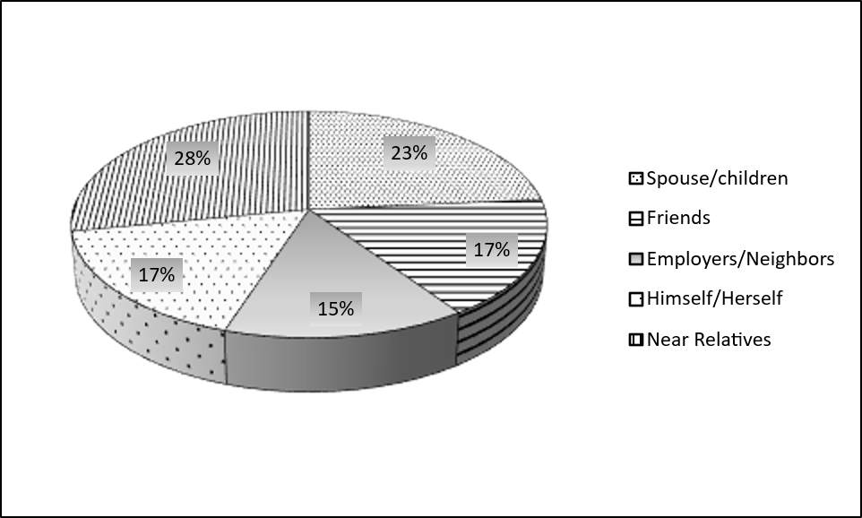
Figure No. 12: Distribution of Migrant Households by Responsible Person for Decision Making to Migrate

Consequences of Migration
While the previous section examined the causes that led migrant households to leave their place of origin, migration also brings about a range of consequences at the place of destination, both positive and negative. These consequences may be reflected in the migrants' satisfaction with their current place of residence, the problems they continue to face after settling in Shankharapur Ward 9 (Sankhu), their future intention to remain there, and the changes they have experienced in aspects of their lives such as culture, occupation, food habit and access to education. This section examines these consequences in turn, drawing on the responses obtained through the questionnaire survey.

Satisfaction with Current Place of Residence
Satisfaction with the current place of residence is one of the most direct indicators of the overall consequence of migration for a household, as it reflects the migrant's own assessment of whether the move has met their expectations. In this study, respondents were asked whether they were satisfied with their current place of residence, whether they were not satisfied, or whether their situation felt no different from before migration. Based on the responses obtained through the questionnaire survey, the distribution of migrant households by satisfaction with the current place of residence is presented in the table below.
Table No. 5.2.1: Distribution of Migrant Households by Satisfaction with Current Place of Residence
Satisfaction | No. of Households | Percent (%)
Yes | 79 | 88.8
No | 8 | 9.0
Same as before | 2 | 2.2
Total | 89 | 100.0
Source: Field Survey, 2026.
Table No. 5.2.1 shows that the overwhelming majority of migrant households, 79 out of 89 (88.8%), reported that they are satisfied with their current place of residence, indicating that migration has, for most households, met or exceeded the expectations that motivated the move. Only 8 households (9.0%) reported that they are not satisfied, while a further 2 households (2.2%) reported that their situation feels no different from before migration. This high overall level of satisfaction is consistent with the pattern already observed in Section 5.1.1, where limited infrastructure, job opportunity and market access were the leading reasons for leaving the place of origin: for most households, relocating to Shankharapur Ward 9 (Sankhu) appears to have resolved the very constraints that originally drove them to migrate.
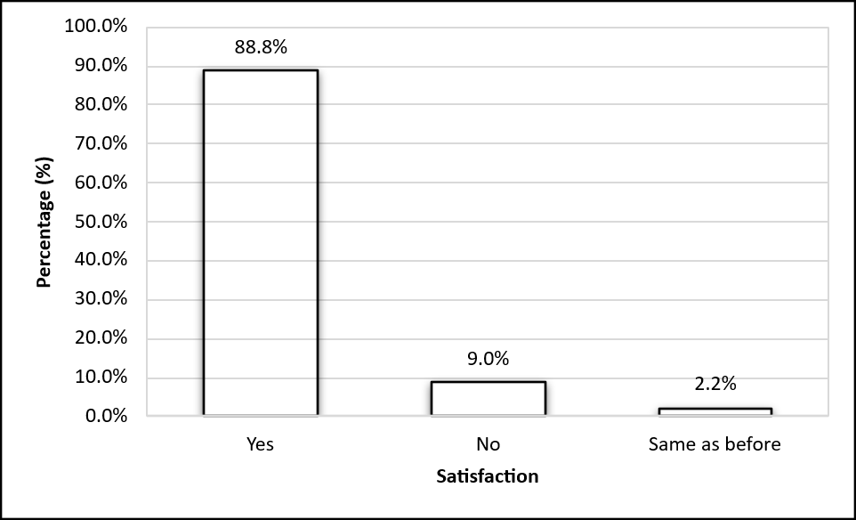
Figure No. 13: Distribution of Migrant Households by Satisfaction with Current Place of Residence

Problems Facing at Destination
Although migration is generally undertaken in search of better opportunities, the place of destination is not always free of difficulties. Identifying the problems that migrant households continue to face after settling in Shankharapur Ward 9 (Sankhu) helps to highlight the gaps that remain in local infrastructure and services despite migration having occurred. In this study, respondents were asked to identify the single most important problem they face at their current place of residence. Based on the responses obtained through the questionnaire survey, the distribution of migrant households by the main problem facing at the current place of residence is presented in the table below.
Table No. 5.2.2: Distribution of Migrant Households by Problems Facing at the Current Place of Residence
Problems | No. of Households | Percent (%)
Inadequate development funding | 35 | 39.33
Insufficient health facilities | 17 | 19.10
Bad social environment | 16 | 17.98
Lack of employment opportunity | 14 | 15.73
Inadequate drinking water supply | 7 | 7.87
Total | 89 | 100.00
Source: Field Survey, 2026.
Table No. 5.2.2 shows that inadequate development funding is the single most commonly reported problem facing migrant households at their current place of residence, cited by 35 households (39.3%) — well ahead of any other single problem. Insufficient health facilities (19.1%) and a bad social environment (18.0%) are the next most frequently reported problems, followed by lack of employment opportunity (15.7%). Inadequate drinking water supply is the least commonly reported problem, cited by only 7 households (7.9%). Taken together, these findings suggest that although migrant households have generally gained better access to physical facilities than at their place of origin (as shown in the causes discussed in Section 5.1.1), local infrastructure and service delivery in Shankharapur Ward 9 (Sankhu) — particularly development funding, health and employment — have not fully kept pace with the sustained inflow of in-migrants, and remain the principal sources of continuing difficulty for migrant households at the destination.
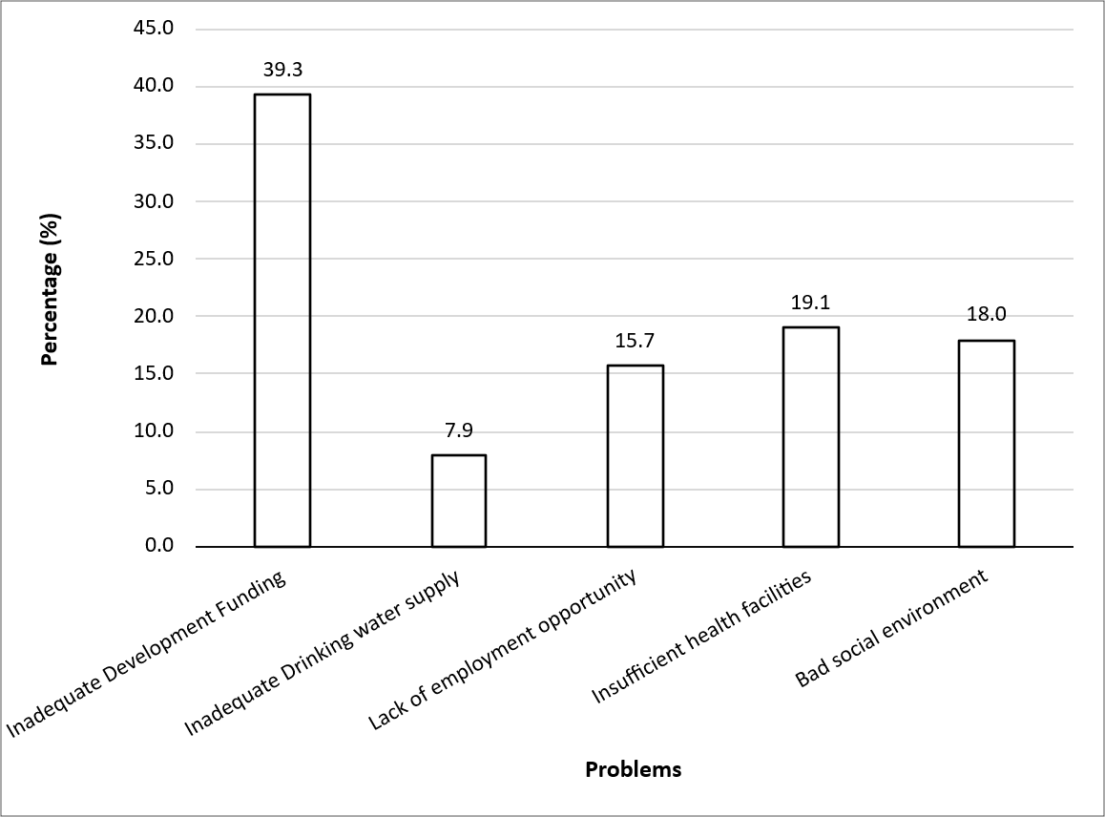
Figure No. 14: Distribution of Migrant Households by Problems Facing at the Current Place of Residence

Permanency of Households in the Study Area
Whether migrant households intend to remain permanently at their current place of residence is an important indicator of the overall success of migration from the migrants' own point of view. A high proportion of households wishing to stay on suggests that migration has largely met their expectations, whereas a notable share wishing to move away again points to unresolved difficulties at the destination. Based on the responses obtained through the questionnaire survey, the distribution of migrant households by their future intention regarding permanent residence is presented in the table below.
Table No. 5.2.3: Distribution of Migrant Households by Future Intention to Live Permanently
Want to Live Permanently | No. of Households | Percent (%)
Yes | 76 | 85.4
No | 13 | 14.6
Total | 89 | 100.0
Source: Field Survey, 2025.
Table No. 5.2.3 shows that a large majority of migrant households, 76 out of 89 (85.4%), intend to live permanently at their current place of residence, while 13 households (14.6%) reported wanting to move to another town or village in the future. This high proportion of households intending to stay on is broadly consistent with the satisfaction levels reported in Section 5.2.1, and suggests that, on balance, migration into Shankharapur Ward 9 (Sankhu) has been a settled and largely successful transition for most migrant households, even though the problems identified in Section 5.2.2 indicate that the destination is not entirely without shortcomings.

Changes in Some Aspects of Migrants
Migration is not only a change of residence but can also bring about changes in the way migrant households live, work and access services. In this study, respondents were asked whether they had experienced any change, since migrating, in four specific aspects of their lives: culture, occupation, food habit, and access to education. Based on the responses obtained through the questionnaire survey, the distribution of migrant households reporting a change in each of these aspects is presented in the table below.
Table No. 5.2.4: Distribution of Migrant Households by Changes in Selected Aspects
Changed Aspect | Yes | Yes % | No. | No %
Culture | 15 | 16.9 | 74 | 83.1
Occupation | 12 | 13.5 | 77 | 86.5
Food Habit | 8 | 9.0 | 81 | 91.0
Better Education | 71 | 79.8 | 18 | 20.2
Source: Field Survey, 2025.
Table No. 5.2.4 shows a clear contrast between the four aspects examined. Access to education stands out as the aspect most commonly affected by migration, with 71 households (79.8%) reporting a change, indicating that improved access to schooling is among the more tangible benefits migrant households have gained at their current place of residence. By contrast, changes in culture (16.9%), occupation (13.5%) and food habit (9.0%) were reported by a much smaller share of households, suggesting that most migrant households have retained their customary practices, occupation and dietary habits even after relocating. This pattern indicates that while migration into Shankharapur Ward 9 (Sankhu) has meaningfully improved access to education for a large share of households, it has not brought about widespread change in the more deeply rooted aspects of household life such as culture and occupation.
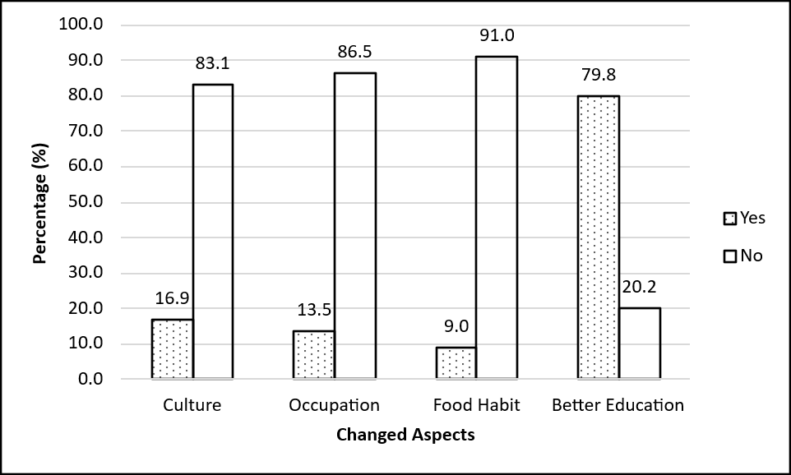
Figure No. 16: Distribution of Migrant Households by Changes in Selected Aspects

Chapter Six

Comparative Analysis of Main Causes and Consequences of Migration
This chapter presents a comparative analysis of the situation of migrant households before and after migration, drawing together the socio-economic indicators discussed separately in the preceding chapters. Comparing conditions at the place of origin with those at the place of destination provides a more direct basis for assessing the extent to which migration has changed the economic and material circumstances of migrant households, going beyond the causes and consequences examined individually in Chapter Five.

Income
Monthly household income is one of the most direct indicators of the economic outcome of migration. In this study, respondents were asked to report their average monthly household income both at their place of origin, prior to migration, and at their current place of residence. Based on the responses obtained through the questionnaire survey, the distribution of migrant households by monthly income at the place of origin and the place of destination is presented in the table below.
Table No. 6.1: Distribution of Migrant Households by Monthly Income at Place of Origin and Place of Destination
Monthly Income (Rs.) | Place of Origin |  | Place of Destination
Monthly Income (Rs.) | No. of HH | Percentage (%) | No. of HH | Percentage (%)
Below 10000 | 6 | 6.74 | 1 | 1.12
10000-19999 | 25 | 28.09 | 10 | 11.24
20000-29999 | 30 | 33.71 | 33 | 37.08
30000-39999 | 19 | 21.35 | 25 | 28.09
40000-49999 | 7 | 7.87 | 15 | 16.85
50000 and above | 2 | 2.25 | 5 | 5.62
Total | 89 | 100.00 | 89 | 100.00
Source: Field Survey, 2025.
Table No. 6.1 shows a clear upward shift in the income distribution of migrant households after migration. At the place of origin, 31 households (34.8%) reported a monthly income below Rs. 20,000, whereas at the place of destination this share fell to 11 households (12.4%). Conversely, the share of households earning Rs. 40,000 or more rose from 9 households (10.1%) at the place of origin to 20 households (22.5%) at the place of destination. The largest single bracket at both places is Rs. 20,000-29,999, but even here the share increased slightly from 33.7 percent to 37.1 percent. Taken together, this pattern indicates that migration into Shankharapur Ward 9 (Sankhu) has, on the whole, been associated with an improvement in the monthly income of migrant households, consistent with the finding in Section 5.1.1 that limited job opportunity and limited market at the place of origin were among the leading reasons for leaving.
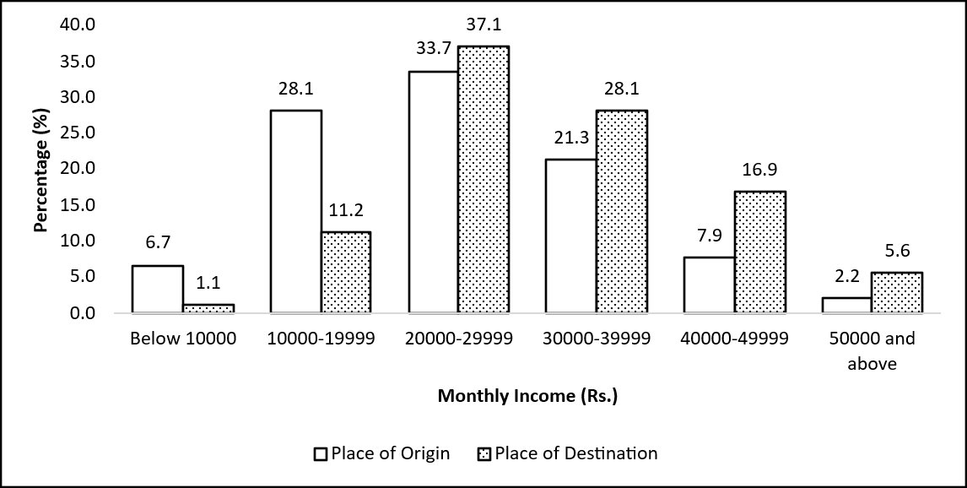
Figure No. 17: Distribution of Migrant Households by Monthly Income at Place of Origin and Destination

Occupation
Occupation is closely linked to household income and is itself often affected by migration, as households may shift into new lines of work upon settling at a new place of residence. In this study, respondents were asked to report their main occupation both at their place of origin and at their current place of residence. Based on the responses obtained through the questionnaire survey, the distribution of migrant households by occupation at the place of origin and the place of destination is presented in the table below.
Table No. 6.2: Distribution of Migrant Households by Occupation at Place of Origin and Place of Destination
Occupation | No. of HHs at Origin | Origin % | No. of HHs at Destination | Destination %
Agriculture | 35 | 39.3 | 32 | 36.0
Business | 21 | 23.6 | 19 | 21.3
Private job | 16 | 18.0 | 17 | 19.1
Other | 7 | 7.9 | 9 | 10.1
Foreign employment | 4 | 4.5 | 4 | 4.5
Government job | 4 | 4.5 | 4 | 4.5
Study/Training | 1 | 1.1 | 3 | 3.4
Not stated | 1 | 1.1 | 1 | 1.1
Total | 89 | 100.0 | 89 | 100.0
Source: Field Survey, 2025.
Table No. 6.2 shows that agriculture remains the single most common occupation of migrant households both before and after migration, although its share has declined somewhat, from 39.3 percent at the place of origin to 36.0 percent at the place of destination. Business shows a similar modest decline, from 23.6 percent to 21.3 percent. In contrast, private job, other occupations, and study/training all show a rise in share, with study/training more than tripling in proportion, from 1.1 percent to 3.4 percent, though this still represents a small absolute number of households. Foreign employment and government job remain unchanged at 4.5 percent each. Overall, the occupational structure of migrant households has shifted only modestly, with a gradual movement away from agriculture toward private-sector employment and other diversified occupations, rather than a wholesale change in livelihood. This is broadly consistent with the income gains observed in Section 6.1, which appear to stem more from a shift within occupational categories than from large-scale occupational transformation.
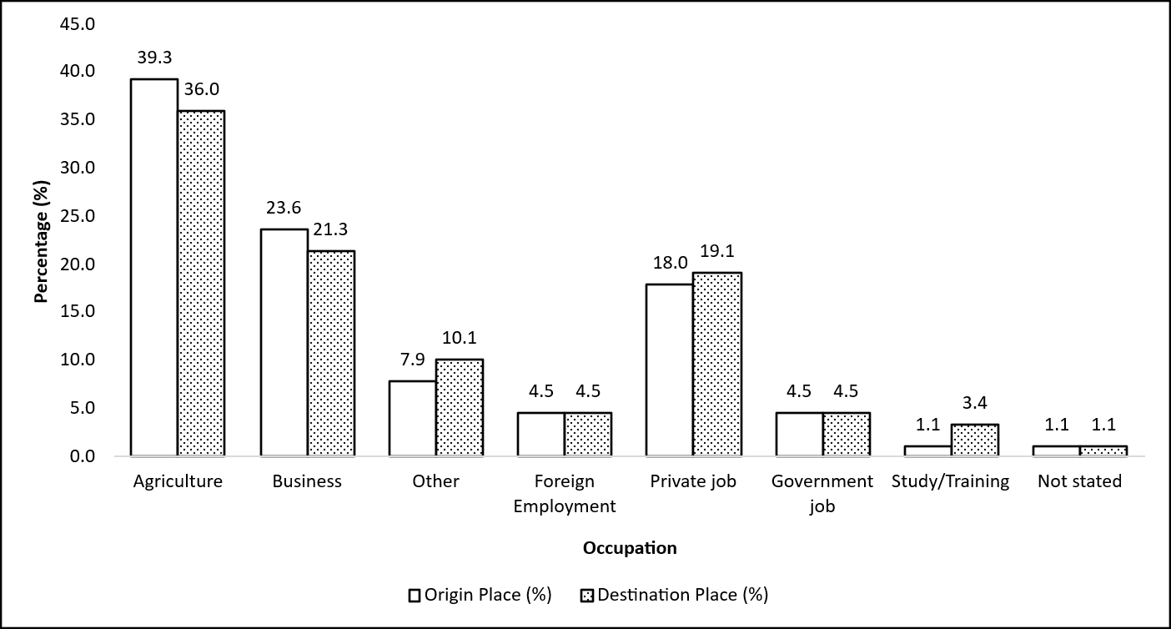
Figure No. 18: Distribution of Migrant Households by Occupation at Place of Origin and Place of Destination

Physical Facilities
Access to physical facilities such as transport, electricity, communication, schooling and health services is a key determinant of the quality of life of a household, and disparities in such access between the place of origin and the place of destination often act as an important pull factor for migration. In this study, respondents were asked to report whether each of these five facilities was available (or was limited/not available) to them both at their place of origin and at their current place of residence. Based on the responses obtained through the questionnaire survey, the comparison is presented in the table below.
Table No. 6.3: Percentage of Migrant Households Reporting Access to Physical Facilities at Place of Origin and Place of Destination
Physical Facilities | Percentage of respondents at Place of Origin |  | Percentage of respondents at Place of Destination
 | Yes (%) | Limited (%) | Yes (%) | Limited (%)
Transport | 67.4 | 32.6 | 100.0 | -
Electricity | 100.0 | 0.0 | 100.0 | -
Communication | 92.1 | 7.9 | 100.0 | -
School | 100.0 | 0.0 | 100.0 | -
Hospital | 38.2 | 61.8 | 100.0 | -
Source: Field Survey, 2025.
Table No. 6.3 shows that access to physical facilities was uneven at the place of origin. Hospital facilities showed the largest gap, with only 38.2 percent of households reporting availability at origin and 61.8 percent reporting it as limited, followed by transport, available to 67.4 percent of households at origin. Electricity and school, by contrast, were already available to all or nearly all households at the place of origin (100.0% and 100.0% respectively), while communication was available to 92.1 percent. At the place of destination, all five facilities were reported as available by 100 percent of households. Given that every facility converges to exactly 100 percent at the destination, this finding should be read with some caution: it may reflect a genuine, near-universal level of physical infrastructure in Shankharapur Ward 9 (Sankhu) given its proximity to urban services, but a uniform 100 percent across all categories could also indicate that the destination-side question was interpreted by respondents as a simple presence/absence check rather than a measure of adequacy, and does not capture possible differences in the quality, reliability or cost of these facilities at the destination. With that caveat noted, the gap between origin and destination is clearly widest for hospital and transport facilities, indicating that improved access to health services and transportation are likely to be among the more significant welfare gains associated with migration into the study area.

Suggestion to the Relatives
After settling at the place of destination, migrants form their own impression of whether the move was worthwhile, and this impression often shapes the advice they give to relatives and friends who are still at the place of origin. Such suggestions can, in turn, influence the future flow of migration into the study area. Respondents were therefore asked what they would suggest to their relatives regarding coming to Shankharapur Ward 9 (Sankhu). The responses are presented below.
Table No. 6.4: Distribution of Migrant Households by Suggestion Given to Relatives
Suggestion to Relatives | No. of Respondents | Percent
Come here | 64 | 71.9
As you like | 20 | 22.5
Go to another place | 5 | 5.6
Total | 89 | 100.0
Source: Field Survey, 2025.
Table No. 6.4 shows that a large majority of respondents, 64 (71.9%), would suggest that their relatives come to this place, indicating a generally positive assessment of the migration experience among the surveyed households. A further 20 respondents (22.5%) said it was up to the relatives themselves to decide (“as you like”), reflecting a neutral stance rather than active discouragement. Only 5 respondents (5.6%) suggested that relatives go to another place instead. Taken together, more than nine in ten respondents (94.4%) gave either a positive or a neutral response, and only a small minority actively discouraged further migration to the study area, which is broadly consistent with the high level of satisfaction with the current place of residence reported in Section 5.2.1.

Impact of Migration in Shankharapur Ward 9 (Sankhu)
The preceding sections have examined the causes, consequences and comparative socio-economic position of migrant households individually. This section draws these threads together to summarize the overall impact of in-migration on Shankharapur Ward 9 (Sankhu), considered under two broad heads: the demographic impact, and the socio-economic impact on migrant households and the destination community.
A. Demographic Impact of In-Migration
Population Growth: The direct demographic effect of in-migration is the addition of 345 persons across 89 households (Table No. 4.2.1) to the population of Shankharapur Ward 9 (Sankhu). Since 73.0 percent of these households moved in from a different district altogether (Table No. 5.1.2), this addition represents a genuine net inflow into the ward rather than a redistribution of population already within the same local area. Because the migrant population is concentrated in the economically active age groups and carries a comparatively low overall dependency ratio of 25.0 (Table No. 4.2.4), the population added by in-migration is weighted toward working-age individuals rather than a large dependent burden. The cross-sectional design of this study does not allow the indirect demographic effects of in-migration, that is, births and deaths occurring among migrant households after their arrival, to be measured directly; the comparatively small children's population recorded in the 0-9 age group (21 persons, Table No. 4.2.1) is consistent with some such natural increase having taken place since settlement, though this cannot be confirmed from the data collected.
Compositional Impact: In-migration has also altered the social composition of the ward relative to the national population. Ethnically, Chhetri (36.0%) and Brahmin (31.5%) households together account for more than two-thirds of migrant households (Table No. 4.1.2), while religiously, Buddhist households are markedly over-represented among migrants (25.8%) relative to their national share (8.21%, NSO, 2021), and Hindu households, while still the majority, fall short of their national share (67.4% against 81.19% nationally) (Table No. 4.1.3). In-migration has therefore contributed to a social composition in the ward that differs in some respects from the national pattern.
B. Socio-Economic Impact of In-Migration
Social Impact: The decision to migrate was, in most cases, family-mediated rather than purely individual: decisions attributed to near relatives, spouses or children together account for more than half of all households (51.7%, Table No. 5.1.3), suggesting that migration has generally reinforced rather than weakened kinship networks between the place of origin and the place of destination. Among the aspects of life most visibly affected by migration, access to education stands out, with 79.8 percent of households reporting improvement (Table No. 5.2.4), indicating a tangible social benefit for migrant families. By contrast, comparatively few households reported a change in culture (16.9%), suggesting that migrant households have largely retained their customary practices and identity rather than assimilating wholesale into a new social environment. At the same time, a bad social environment was reported as the main difficulty by 18.0 percent of households (Table No. 5.2.2), indicating that social friction at the destination remains a live concern for a meaningful minority.
Economic Impact: Migration is associated with a clear improvement in household income: the share of households earning below Rs. 20,000 per month fell from 34.8 percent at the place of origin to 12.4 percent at the place of destination, while the share earning Rs. 40,000 or more rose from 10.1 percent to 22.5 percent (Table No. 6.1). This economic gain, however, has been achieved mainly through improved returns within existing lines of work rather than wholesale occupational change: agriculture remains the single most common occupation both before and after migration, declining only modestly from 39.3 percent to 36.0 percent (Table No. 6.2). Land ownership is near-universal among migrant households at the destination (Table No. 4.1.4), which, together with the reported universal access to physical facilities such as transport, electricity, communication, schooling and health services (Table No. 6.3, read with the caveat noted in that section), points toward a generally improved asset and infrastructure base for migrant households after settlement.
Quality of Life: Taken together, these demographic, social and economic effects are reflected in migrant households' own assessment of their move. A large majority report being satisfied with their current place of residence (88.8%, Table No. 5.2.1), intend to live there permanently (85.4%, Table No. 5.2.3), and would suggest that relatives come to the same place or leave the decision to them (94.4% combined, Table No. 6.4). These positive assessments should nonetheless be read alongside the problems that a meaningful share of households continue to report at the destination, particularly inadequate development funding (39.3%), insufficient health facilities (19.1%) and lack of employment opportunity (15.7%) (Table No. 5.2.2), which indicate that local infrastructure and service delivery in Shankharapur Ward 9 (Sankhu) have not fully kept pace with the scale of in-migration into the ward.
On the whole, in-migration into Shankharapur Ward 9 (Sankhu) appears to have had a predominantly positive impact on migrant households in demographic, social and economic terms, while at the same time placing continuing pressure on local infrastructure and services that has not fully kept pace with the volume of inflow.

Chapter Seven

7. Summary, Conclusion and Recommendation

Summary
This study has examined the trends, causes and consequences of in-migration in Shankharapur Ward 9 (Sankhu), Kathmandu, based on a complete enumeration of 89 migrant households comprising 345 persons. The main findings are summarized below.
In terms of socio-economic characteristics, the migrant population is predominantly literate (80.9%), though a marked gender gap remains, with literacy among females (66.9%) considerably lower than among males (93.7%). Migrant households are drawn primarily from the Chhetri (36.0%) and Brahmin (31.5%) ethnic groups, and are predominantly Hindu (67.4%), with a Buddhist share (25.8%) notably higher than the national average. Nearly all migrant households (69.7%) hold relatively small land parcels measured in Aana, and all 89 households reported owning some land, consistent with the municipality's requirement of land ownership for migrant status. Piped water is the leading source of drinking water (53.9%), supplemented by boring (39.3%).
Demographically, the migrant population is fairly balanced by sex (181 males, 164 females; a sex ratio of approximately 110 males per 100 females) and is concentrated in the economically active age groups, with an overall age dependency ratio of only 25.0. Among migrants aged 10 years and above, 62.0 percent are currently married. The average family size of migrant households is 3.88 persons, smaller than both the national average of 4.37 (NSO, 2021) and closely matching the Bagmati Province average of 3.89.
Regarding the causes of migration, limited infrastructure (34.8%), limited job opportunity (27.0%) and limited market access (20.2%) at the place of origin were the leading reasons households reported for leaving, together accounting for more than four-fifths of all households. The large majority of migrant households (73.0%) moved from a different district altogether, and migration decisions were, in more than half of cases (51.7%), made or influenced by near relatives, spouses or children rather than by the migrant alone.
Regarding the consequences of migration, satisfaction with the current place of residence is high (88.8%), and a large majority of households (85.4%) intend to live there permanently. Access to education is the aspect of life most commonly reported as improved after migration (79.8%), while changes in culture, occupation and food habit were reported by comparatively few households, indicating that migrants have largely retained their customary practices. At the same time, inadequate development funding (39.3%), insufficient health facilities (19.1%) and a bad social environment (18.0%) remain the most commonly reported problems at the destination.
The comparative analysis of conditions before and after migration shows a clear improvement in household income, with the share of households earning below Rs. 20,000 per month falling from 34.8 percent at the place of origin to 12.4 percent at the destination, and the share earning Rs. 40,000 or more rising from 10.1 percent to 22.5 percent. This income gain has occurred alongside only a modest shift in occupational structure, with agriculture remaining the single most common occupation both before (39.3%) and after (36.0%) migration. A large majority of respondents (71.9%) would suggest that their relatives come to Shankharapur Ward 9 (Sankhu), and a further 22.5 percent would leave the decision to them, together indicating a broadly positive assessment of the migration experience.

Conclusion
The findings of this study indicate that in-migration into Shankharapur Ward 9 (Sankhu) is driven predominantly by economic and infrastructural push factors at the place of origin, particularly limited infrastructure, limited job opportunity and limited market access, rather than by social, political or conflict-related causes. The predominance of inter-district migration, together with the strongly family-mediated nature of the migration decision, suggests that kinship networks play an important role in directing the flow of migration toward this study area.
The consequences of migration, on balance, appear favourable for migrant households: incomes have risen markedly after migration, satisfaction with the current place of residence is high, and the large majority of migrant households intend to remain permanently and would recommend the area to relatives. The demographic profile of the migrant population, concentrated in the working-age groups with a comparatively low dependency ratio, is consistent with migration driven primarily by livelihood motives rather than by dependents accompanying working members.
At the same time, this generally positive picture should be read alongside the problems that a meaningful share of migrant households continues to report at the destination, particularly inadequate development funding, insufficient health facilities and lack of employment opportunity. These findings suggest that while migration has, on the whole, improved the economic circumstances of migrant households, local infrastructure and service delivery in Shankharapur Ward 9 (Sankhu) have not fully kept pace with the sustained inflow of migrants, and continued in-migration is likely to place further pressure on these services unless addressed.

Recommendation
On the basis of the findings of this study, the following recommendations are made for the concerned local authorities and stakeholders:
- Development funding and basic infrastructure in Shankharapur Ward 9 (Sankhu) should be strengthened, as inadequate development funding was the single most commonly reported problem among migrant households (39.3%) and is likely to become more pressing as in-migration continues.
- Health facilities at the destination should be improved and expanded, given that insufficient health facilities were the second most commonly reported problem (19.1%) despite health infrastructure already being comparatively better at the destination than at the place of origin.
- Local employment opportunities should be expanded, since lack of employment opportunity remains a reported problem for a meaningful share of households (15.7%) even after migration, and limited job opportunity was itself among the leading reasons households left their place of origin.
- The municipality should formally confirm and document the exact year and terms of the land-ownership requirement for migrant status referenced in Section 4.1.4 of this study, so that the administrative basis for this requirement is clearly recorded for future reference and research.
- Since female literacy (66.9%) remains substantially lower than male literacy (93.7%) among the migrant population, targeted adult literacy and education programmes for women should be considered.
- Future studies on migration into this study area should collect household-level data capable of supporting cross-tabulations, such as ethnicity by occupational mobility, which the present study, based on aggregate tables, was not able to construct.

References
Centre for Economic Development and Administration. (1973). Migration in Nepal: Implication for spatial development: A Project Proposal, Kathmandu. C. f. E. D. a. A. (CEDA).
Centre for Economic Development and Administration. (1977). Migration in Nepal: A study of the Far-Western Development Region. Centre for Economic Development and Administration.
Gurung, H. B. (1974). Seminar on Population and Development.
Gurung, H. B. (1984). Regional patterns of migration in Nepal. Papers of the East-West Population Institute.
KC, B. K. (1993). Urbanization and migration in Nepal. Preparatory Seminar for the International Conference on Population and Development.
KC, B. K. (1998). Trends, patterns and implications of rural-to-urban migration in Nepal. Central Department of Population Studies (CDPS), Tribhuvan University.
KC, B. K. (2003). Central Bureau of Statistics. https://dics.censusnepal.cbs.gov.np
Kunwar, L. S. (1993). Causes and consequences of internal migration in Nepal: A case study of Bharatpur Municipality, Chitwan. Tribhuvan University.
Kunwar, L. S. (2015). Causes and consequences of internal migration in Nepal: A case study of Bharatpur Municipality, Chitwan (Unpublished master’s thesis). Central Department of Population Studies, Tribhuvan University.
Lee, E. S. (1966). A theory of migration. Demography, 47–57.
Mabogunje, A. L. (1970). Systems approach to a theory of rural–urban migration. Geographical Analysis, 1–18.
National Statistics Office. (2021). National Population and Housing Census 2021. N. S. Office.
Niroula, P. (2016). Internal migration. In Population monograph of Nepal. Central Bureau of Statistics; National Planning Commission Secretariat.
Ravenstein, E. G. (1885). The laws of migration. Journal of the Statistical Society of London, 167–235.
Stewart, Q. J. (1950). The development of social physics. American Journal of Physics, 239–253.
Subedi, B. P. (1996). Dominant approaches to population mobility: An appraisal and the common ground. Geographical Journal of Nepal, 17–37.
Todaro, M. P. (1976). Internal migration in developing countries: A review of theory, evidence, methodology, and research priorities. International Labour Organization.
United Nations. (1973). United Nations Multilingual Dictionary.
United Nations Population Fund. (1993). The state of world population. United Nations.
Zipf, G. K. (1946). The P1 P2/D hypothesis: On the intercity movement of persons. 677–686.

APPENDIX: Research Questionnaire
Questionnaire for the Data Collection of Causes and Consequences of In-Migration in Shankharapur Municipality Ward No. 9, Kathmandu District
Part I: Household Information
Section A: Introduction
District: Kathmandu
Municipality: Shankharapur
Ward No.: 9
Tole: _____________________
Household Family Size.: _____________________
Name of Household Head: _____________________
Name of Respondent: _____________________
Religion:
1) Hindu 2) Buddhist 3) Muslim 4) Christian 5) Others
Section B: Household Survey Schedule
S.N. | Name | Relation to the HH | Sex | Age | Literacy Status | Marital Status | Occupation | Remark
 |  | A | B |  | C | D | E
1
2
3
4
5
6

* Codes for Household Survey Schedule column values are listed below under structural tables.
Code for A | Code for B | Code for C | Code for D | Code for E
1.House Head | 1.Male | 1.Literate | 1.Unmarried | Agriculture
2.Husband/Wife | 2.Female | 2.Illiterate | 2.Married | Business
3.Sun/Daughter |  |  |  | Private job
4.Son/Daughter in law |  |  |  | Other
5.Grand child |  |  |  | Foreign employment
6.Father/Mother |  |  |  | Government job
7.Father/mother in law |  |  |  | Study/Training
8.Nephew/Niece |  |  |  | Not stated
9.Brother/Sister
10.Other Relatives

Section C: Socio-Economic Characteristics of Household
1 | How much land is owned by the household? | 1. Ropani  2. Aana  3. Paisa  4. Daam  5. Others
2 | Can you tell me the main source of drinking water? | 1. Piped  2. Boring  3. Well
Part III: Questionnaire for Causes of In-Migration
3 | Main reason for migration to this place? | - Limited Market  - Limited Arable Land  - Limited Job Opportunity  - Limited Infrastructure  - Government Job  - Victim of Conflict
4 | Previous place of residence? | - Same palika  - Other palika of same district  - Other district
5 | Responsible Person for decision making to migrate?
  - Himself/Herself
  - Spouse/children
  - Near Relatives
  - Friends
  - Employers/Neighbors
6 | Did your previous place have transportation facilities? | - Yes  - Limited
7 | Did your previous place have healthcare facilities? | - Yes  - Limited
8 | Did your previous place have good schools/colleges? | - Yes  - Limited
9 | Did your previous place have communication facilities? | - Yes  - Limited
10 | Did your previous place have good electricity facilities? | - Yes  - Limited
11 | Ethnic group? | - Brahmin  - Chhetri  - Janajati  - Dalit
12 | Main occupation before migration? | - Agriculture  - Business  - Foreign Employment  - Private job  - Government job  - Study/Training  - Not Stated  - Other
13 | Who mainly decided migration? | - Self  - Spouse/Children  - Near relatives  - Friends  - Employers/Neighbors
14 | Monthly income before migration? | - Below 10000  - 10000-19999  - 20000-29999  - 30000-39999  - 40000-49999  - 50000 & above
15 | Did unemployment influence migration? | 1. Yes  2. No
16 | Did lack of agricultural land influence migration? | 1. Yes  2. No
17 | Did better education opportunities influence migration? | 1. Yes  2. No
18 | Did better infrastructure influence migration? | 1. Yes  2. No
19 | Did family networks influence migration? | 1. Yes  2. No
Part IV: Questionnaire for Consequences of In-Migration
20 | Are you settled permanently in this area? | - Yes  - No
21 | Has migration improved household income? | - Yes  - No
22 | Monthly income now? | - Below 10000  - 10000-19999  - 20000-29999  - 30000-39999  - 40000-49999  - 50000 & above
23 | Is your current residence area satisfactory? | - Yes  - No  - Same as before
24 | Do you want to continue living here permanently? | - Yes  - No
25 | Where do you like to live in near future, if no? | …………………………………..
26 | Main problems faced after migration? | - Inadequate development funding  - Insufficient health facilities  - Bad social environment  - Lack of employment opportunity  - Inadequate drinking water supply
27 | Has migration improved transportation access service? | - Yes  - No
28 | Is there any electricity problem here? | - Yes  - No
29 | Do you have got any communication service problems here? | - Yes  - No
30 | Has migration improved healthcare access? | - Yes  - No
31 | Has migration changed cultural practices? | - Yes  - No
32 | Has your occupation changed after migration? | - Yes  - No
33 | If yes, what is your occupation now? | - Agriculture  - Business  - Foreign Employment  - Private job  - Government job  - Study/Training  - Not Stated  - Other
34 | Has migration changed your food habits? | - Yes  - No
35 | Has migration improved educational institution accessible? | - Yes  - No
36 | What would you suggest to relatives/friends? | - Come Here  - Go to another place  - As you like

